**Section 2: Arrays & Big O Notation**

**Big O Notation**

* 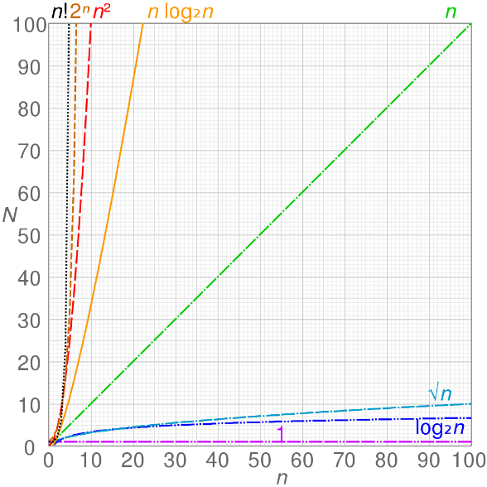**Time complexity** is the number of steps that it takes to run the algorithm
* Memory complexity is the amount of memory that it takes to run the algorithm
* Uses the worst-case scenario
* **Constant** - O(1)
* **Logarithmic** - O(log(n))
* **Linear** - O(n)
* **n log-star n** - O(n*log(n))
* **Quadratic** - O(n2)

**Arrays in Java**

**\*GitHub\***

**Arrays in Memory**

* One contiguous block in memory, they are not scattered
* Static
* Every element occupies the same amount of space in memory
* If an array starts at memory address **X**, and the size of each element in the array is **Y**, we can calculate the memory address of the **ith**element by using the following expression (assuming you know the starting address): **X + i * Y**
* If we know the index of the element in the array, the time to retrieve the element will be the same no matter where it is in the array
* **NOTE:** useful for retrieving elements if we know the index, the time is the same for each element

**Big O Values for Array Operations**

**Retrieve an Element from an Array**

1. Multiply the size of the element by its index
2. Get the start address of the array
3. 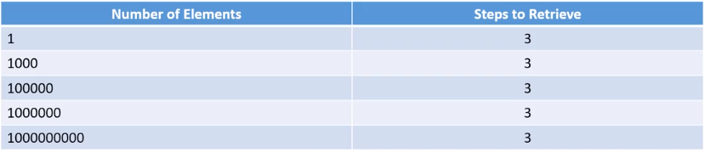Add the start address to the result of the multiplication

**Big O Value**

* Time complexity is **constant** because the steps to retrieve an element is always three steps no matter the size of the array
* 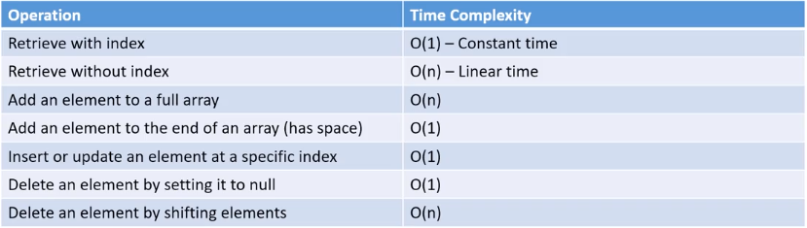**O(1)**

**Operations**

* In the operations if we must loop over the array to perform the operation, that’s going to have a **linear** time complexity
* If we can calculate the index, instead of looping, then that will have a **constant** time complexity